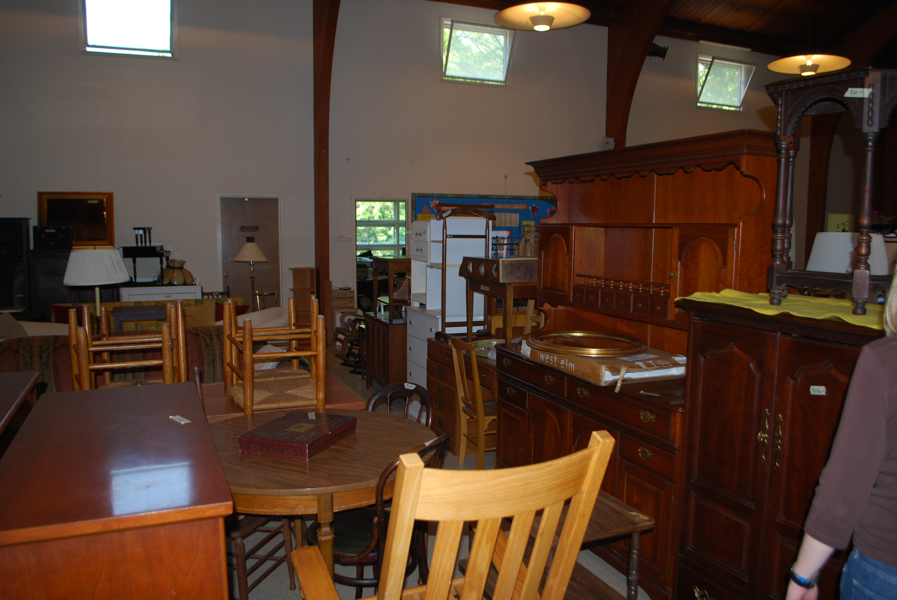

##### Donations are accepted from June 18st up until Sept. 3rd, unless max capacity is reached sooner.

##### Donations may be dropped off in the auditorium of the church Monday-Friday between the hours of 9am -3 pm.

**FURNITURE PICK -UP DATES:**

**Saturday, June 25th Saturday, July 16th**

**Saturday, August 13th**

Suggested fee for pick up is $30 if within 10 miles of IPC. If beyond 10 miles then special arrangements need to be made.

Friday, September 9th from 10 am – 5 pm

Saturday, September 10th from 10 am - 3 pm

25 North Broadway, Irvington, NY 10533

2016 ATTIC SALE

##### Drop-offs can be made for other times by calling **914-591-8124**

##### **or emailing ipcsecretary**

##### **@aol.com**

**NEED TO DE-CLUTTER & PURGE ITEMS FROM YOUR HOME**

Irvington Presbyterian church

#### You can bring them to the IPC Attic Sale!

Accessories

Bakery

Books

Boutique

Café

Children’s Clothing & Shoes

Electronics

Furniture

Holiday

Housewares

Linens

Men’s Clothing & Shoes

Sporting Goods

Toys

Women’s Clothing & Shoes

and more!

### Our Departments

### the

Midnight Run

National Children’s Cancer Center

Rosary Hill

Rural & Migrant Ministries

Safe Horizons

Salvation Army Food Pantry

Sharing Community Food Kitchen

Smile Train

Spring Community Partners of Dobbs Ferry

St. Cabrini Adult Day Health Center

Tarrytown Ambulance Corp.

The Bowery

Trickle Up

West Hab

Westchester Boy Scout Council

Westchester Coalition for Hungry & Homeless

Women of Grace Widows Fund

Salvation Army

Westchester Animal Shelter

Midnight Run

SPRING Community Partners of Dobbs Ferry

Queen Daughter Day Nursery in Yonkers

Saint Barnabas Church of Irvington

Furniture Share House of Westchester Co.

Exodus

The Bowery of NYC

AFYA of Yonkers

New Beginnings in Elmsford

P.S. 56, Norwood Heights School

Vietnam Veterans of America

Abbott House

Autism Speaks

Bedford Hills Correctional Children’s Center

Boys & Girls Club of Tarrytown & Sleepy Hollow

Children’s Village

CLUSTER

Dobbs Ferry Food Pantry

Dobbs Ferry Volunteer Ambulance Corp

Elizabeth Mascia Child Care Center

Exodus Transitional Community, Yonkers

Family Services of Westchester

FISH of Irvington

Good Shepherd Early Childhood Center Scholarship Fund

Guiding Eyes for the Blind

Heifer International

Habitat for Humanity

Helping Hands of Potsdam, NY

Holmes Presbyterian Camp

Hope’s Door/Northern Westchester Shelter

Hour Children

Hunger Project

Hurricane Sandy Relief

Irvington Senior Center

Irvington Volunteer Ambulance Corp.

Irvington Volunteer Fire Dept.

Lighthouse International

Make-a-Wish Foundation

Medical Benevolence Foundation

My Sister’s Place

Pegasus Therapeutic Riding

Peter M. Goodrich Foundation

Pets Alive Animal Shelter

Phelps Memorial Hospice

Puppies Behind Bars

PW Mission Pledge

**If you would give it to a friend you can give it to the attic sale.**

ITEMS **NOT** ACCEPTED ARE: Car & booster seats, old style TVs & computer monitors, and mattresses & box springs. Any items that are broken, torn or stained are not accepted.

FURNITURE should be in satisfactory condition. Broken, stained or torn items are not accepted. Items must be under 6’ high and no more than 6’ wide. All items must pass easily through a normal door.

Furniture items must be under 6 feet high and no more than 6 feet wide. All items must pass easily through a normal door.

No Mattresses or Box Springs will be accepted. Bed frames can be donated.

Furniture items must be under 6 feet high and no more than 6 feet wide. All items must pass easily through a normal door.

Excessively Large Furniture Items

**DONATION GUIDELINES**

Remember to request a donation tax form when you drop your items off.

**Proceeds & remaining items from previous IPC Attic Sales have gone to the following charities:**